**Operating System Lab**

**Fall 2024**

**Lab 11 Task**



**Name: Alishba Waqar**

**Sap id: 46997**

**BSCS-5**

**Lab Instructor:**

**Kausar Nasreen Khattak**

**Email:**

**kausar.nasreen@riphah.edu.pk**

**Lab Task**

**Note:** Include screenshots, where required to illustrate your explanation.

**Q1.** How do you create a basic for loop in a shell script to iterate over a list of numbers from 1 to 5?

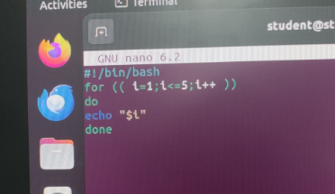

**Q2.** What is the syntax for a while loop that counts from 1 to 10 and prints each number?

**Q3.** How would you write a nested loop in shell scripting to print a multiplication table from 1 to 3?

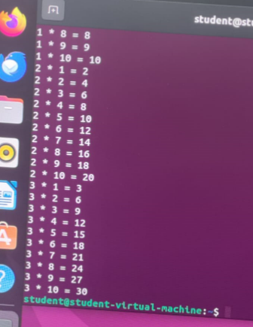

**Q4:** Write a for-in loop that iterates over the items in an array named fruits containing apple, banana, and cherry.

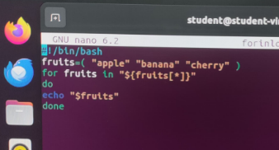

**Q5:** Write a while loop that reads user input until the user types "exit".

